

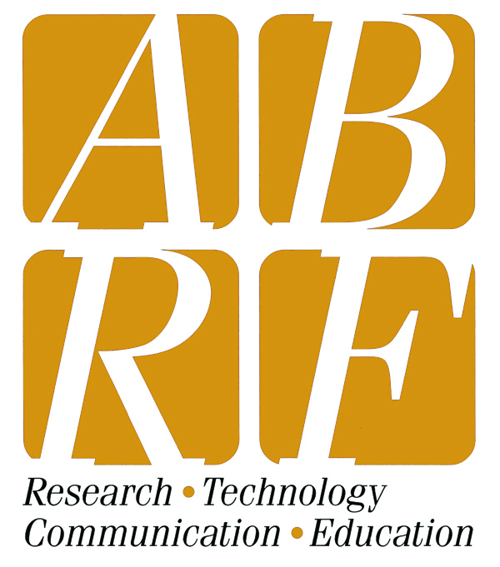
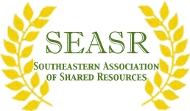

Business Skills for Core Directors, Managers
and Administrators
Presented by
Darden Executive Education Faculty,
Darden School of Business
University of Virginia, Charlottesville VA
June 2-3, 2015
(Precedes the Joint Conference of the SEASR and MAD SSCi June 3-5, 2015)

This 2-day workshop will cover the necessary business skills for core personnel to effectively improve their core’s operation:
- Deepen essential business and financial acumen
- Sharpen ability to use financial data in business decision making
- Establishing service pricing
- Strategic decision Making and Marketing
- Creating a high performing and customer oriented core facility
- Strategic thinking and Analysis
To learn more about this exciting opportunity and receive event updates, please contact the
MAD SSCi/SEASR Planning Committee: Janette.Lamb@madssci.abrf.org

